Functional Specification – Properties Panel: Details

|  |  |
| --- | --- |
| Document Information | |
| Title: | Properties Panel: Details |
| Author: | Lara van der Spuy |
| Date: | 10-09-2018 |
| Owner: | Pragma R&D |

|  |  |  |
| --- | --- | --- |
| Change History | | |
| Date | Description | Responsible Person |
| 10-09-2018 | Initial Draft | Lara van der Spuy |
|  |  |  |
|  |  |  |

Contents

1. Context 2

1.1 Background 2

1.2 Purpose 2

2. Related Documents 4

3. On Key Plus Requirements: Detail Collection Panel 4

3.1 Summary of Requirements 4

3.2 Use Cases Related to Requirements 4

3.3 Requirements 4

4. On Key Plus Requirements: Detail Edit 5

4.1 Summary of Requirements 5

4.2 Use Cases Related to Requirements 5

4.3 Requirements 5

5. User Rights 5

6. Default Layout 6

7. On Key 5 Design 6

8. Previous On Key 5 Modification in this Area 6

9. Additional Features for Future 6

9.1 *Permit Required (possible additional feature)* 6

Click or tap here to enter text.

1. Context
   1. Background

In On Key Plus a lot of emphasis is placed on customisation of the user interface. Users will be allowed to setup up dashboard views consisting of a variety of properties and visualisation types. The focus is not to build a Business Intelligence tool, but to allow the users to configure visualisations to enable users to interact with the data.

* 1. Purpose

The purpose of the properties panel is to view settings and controls in the context of your current visualisation. Designs with ease of use in mind, ensuring that you have access to the right controls when you need them. The Properties panel is available in both the Dashboard and Details Views. When an item is selected in the DRC, the related properties will become available. Use Cases

|  |  |  |  |  |
| --- | --- | --- | --- | --- |
| Who | What | Why | Feature | Priority |
| On Key Consultant | Setup a dashboard for the AC Manager and Call Centre Agents that will be managing the new call centre. | Configure custom views for users with different roles. | Details Properties Panel. | High |
| Data Capturer | Hide work request data fields | Increases efficiency when only requiring to capture work order feedback | Display or hide fields on a record. | High |
| AC Manager | A work order is issues to a technician for repairs required. The work order also has a PO number field to show the contractor that a PO has been required, therefore the work has been approved. The technician should however not be able to change this field. | It is merely a reference for the contractor. | Configure a field to be read-only. | High |
| AC Manager | In a call centre, some of the information requiring to be captured by the agent is mandatory and the work order cannot be issued unless the information is required. | Ensures that work orders cannot be issued unless the required information is captured. | Configure a field to be required. | High |
| AC Manager | In a call centre, some of the information requiring to be captured by the agent is mandatory and the work order cannot be issued unless the information is required (red). Other information is optional (orange), however the agent still needs to ask the caller for the information. Other information is not required at all (white). | Visual aid to the users to ensure they remember what fields are required. | Configure the background colour of a field on a record. | Low |
| AC Engineer | Change the Work Required Field label to “Request” | Companies may have different references to fields or the use thereof. | Configure the label of a field on a record. | High |
| Project Engineer | Group all the work order feedback fields under a group called “Technician Feedback” | Companies may have different references to fields or the use thereof. | User configurable field groupings. | Medium |
| Project Engineer | Group all the work order feedback fields under a tab called “Technician Feedback” | Companies may have different references to fields or the use thereof. | User configurable tabs. | Medium |
|  | The collection Panel is used to move between records. The information being displayed should be configurable. | Easier navigation or identification of records. | Configure visible information in Details Collection Panel.  Template for collection panel design.  Configure template values for the collection panel designs. | Low |

1. Related Documents

$/OKSource/OnKeyPlus/Documentation/Requirements/DRC/PropertiesPanel_Requirements.docx

1. On Key Plus Requirements: Detail Collection Panel
   1. Summary of Requirements

* Configure visible information in Details Collection Panel
* Template for collection panel design
* Configure template values
  1. Use Cases Related to Requirements

|  |  |
| --- | --- |
| Who | What |
| On Key Consultant | Setup a dashboard for the AC Manager and Call Centre Agents that will be managing the new call centre. |
| Data Capturer | Hide work request data fields |
| AC Manager | A work order is issues to a technician for repairs required. The work order also has a PO number field to show the contractor that a PO has been required, therefore the work has been approved. The technician should however not be able to change this field. |
| AC Manager | In a call centre, some of the information requiring to be captured by the agent is mandatory and the work order cannot be issued unless the information is required. |
| AC Manager | In a call centre, some of the information requiring to be captured by the agent is mandatory and the work order cannot be issued unless the information is required (red). Other information is optional (orange), however the agent still needs to ask the caller for the information. Other information is not required at all (white). |
| AC Engineer | Change the Work Required Field label to “Request” |
| Project Engineer | Group all the work order feedback fields under a group called “Technician Feedback” |
| Project Engineer | Group all the work order feedback fields under a tab called “Technician Feedback” |

* 1. Requirements

|  |  |  |
| --- | --- | --- |
| Feature | Requirements | Why |
| Display or hide fields on a record. | Have a list of fields of the current record visible  In the list tick to configure which fields are visible and which fields are not. | Hide irrelevant data that the user does not need to see.  Protect data or information |
| Configure a field to be read-only. | Have a list of fields of the current record visible  In the list tick to configure which fields are read only and editable. | Some fields are only used as a reference and should not be updated. |
| Configure a field to be required. | Have a list of fields of the current record visible  In the list tick to configure which fields are required | Ensures that all information required can be captured. |
| Configure the background colour of a field on a record. | Select a field on a edit window and select a background colour. | Visual aid to the users to ensure they remember what fields are required. |
| Configure the label of a field on a record. | List all the columns in the table and have an additional column to display the names of the columns being displayed. | Companies may have different references to fields or the use thereof. |
| User configurable field groupings. | Have a section that shows all of the groupings and under which tab it falls.  Allow users to move fields in and out of tabs and groups and change the label of the group or tab. | Companies may have different references to fields or the use thereof. |
| User configurable tabs. | Have a section that shows all of the groupings and under which tab it falls.  Allow users to move fields in and out of tabs and groups and change the label of the group or tab. | Companies may have different references to fields or the use thereof. |

1. On Key Plus Requirements: Detail Edit
   1. Summary of Requirements

* Configure visible information in Details Collection Panel.
* Template for collection panel design.
* Configure template values for the collection panel designs
  1. Use Cases Related to Requirements

* 1. Requirements

1. User Rights

|  |  |  |  |  |
| --- | --- | --- | --- | --- |
| Module | Sub Module | Object | User Right | Notes |
| Properties Panel | None | Details | View |  |
| Properties Panel | None | Details | Change |  |
| Properties Panel | None | Details Collection | View |  |
| Properties Panel | None | Details Collection | Change |  |

1. Default Layout
2. On Key 5 Design

Define the current “as is”. This only assists the analysts in obtaining all the requirements.

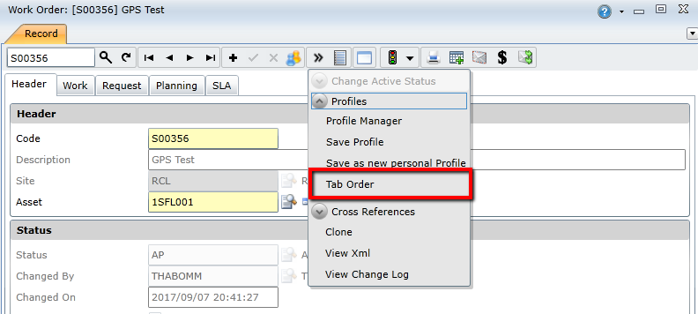

1. Previous On Key 5 Modification in this Area

Please list previous modifications for this module or feature

1. Additional Features for Future

As you analyse you will come across many requirements that are not in scope. Please add them here and make sure they are logged as mods in AHA.

*Example:*

* 1. *Permit Required (possible additional feature)*

*Not in scope for now.*

*Users would like to specify which permit is required to work on this asset.*